

NAME OF THE PROJECT

Submitted by:

Ruchiita Parmar

**ACKNOWLEDGMENT**

I am used internet and web side to use this project and also use my intitule recorded classes and other channel, and other resources that helped me and guided me in completion of the project.

**INTRODUCTION**

Business Problem Framing

Car price prediction is somehow interesting and popular problem. As per information that was gotten from the Agency for Statistics of BiH, 921.456 vehicles were registered in 2014 from which 84% of them are cars for personal usage [1]. This number is increased by 2.7% since 2013 and it is likely that this trend will continue, and the number of cars will

Accurate car price prediction involves expert knowledge, because price usually depends on many distinctive features and factors. Typically, most significant ones are brand and model, age, horsepower and mileage. The fuel type used in the car as well as fuel consumption per mile highly affect price of a car due to a frequent changes in the price of a fuel.

**Analytical Problem Framing**

* Mathematical/ Analytical Modeling of the Problem

There are two primary phases in the system: 1. Training phase: The system is trained by using the data in the data set and fits a model (line/curve) based on the algorithm chosen accordingly. 2. Testing phase: the system is provided with the inputs and is tested for its working. The accuracy is checked. And therefore, the data that is used to train the model or test it, has to be appropriate. The system is designed to detect and predict price of used car and hence appropriate algorithms must be used to do the two different tasks. Before the algorithms are selected for further use, different algorithms were compared for its accuracy. The well-suited one for the task was chosen..

* Data Sources and their formats

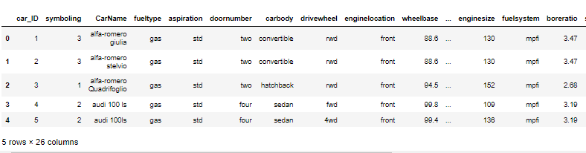

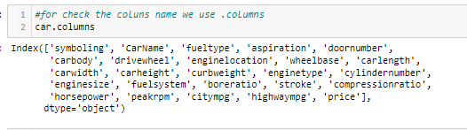

This are the columns that are present in our data set .

* Data Preprocessing Done

For the data pre-processing I have to check the null values

As show below

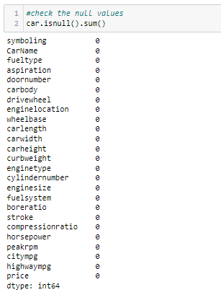

We can clearly seen there is no null value in our data set so move ahead.

* Data Inputs- Logic- Output Relationships

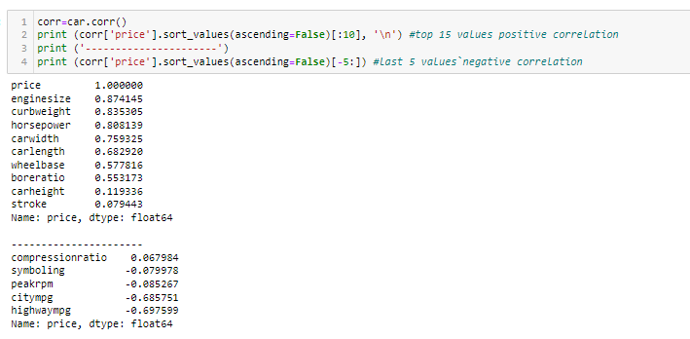

Positive co-relation and negative co-relation show by image.

.

* Hardware and Software Requirements and Tools Used

Use required hard and software like jupyture notebook ,chrome,os,package ,library like sea born graphical representation I done with those tools.

* Visualizations

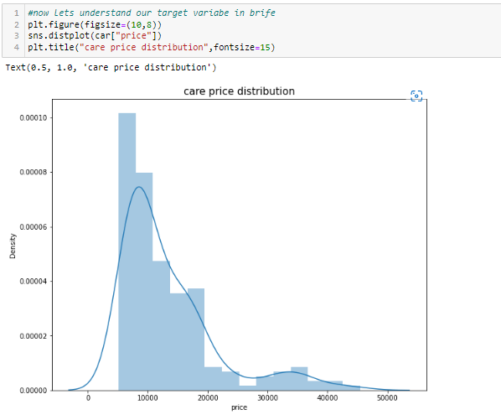

our target variable(price) is right side skew

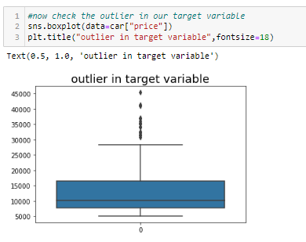

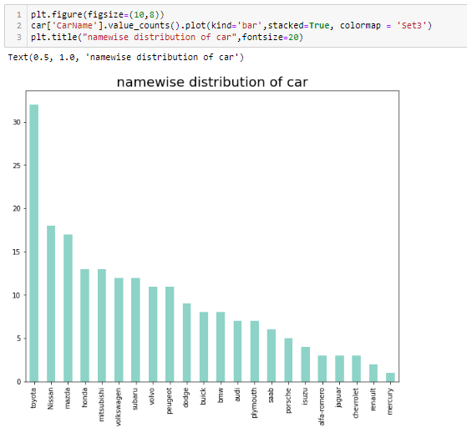

most of people like toyota and very less people

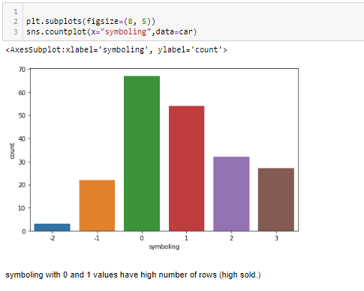

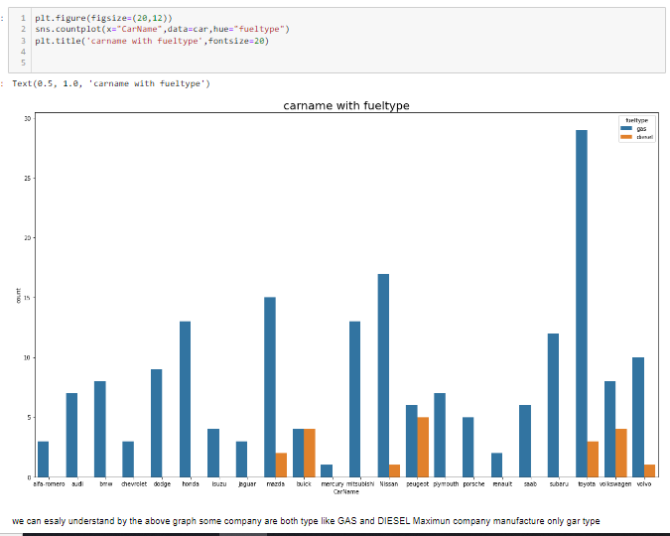

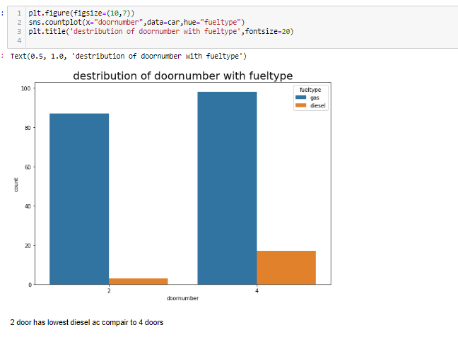

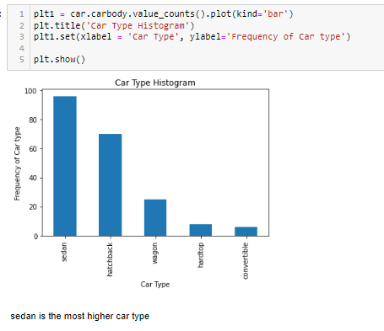

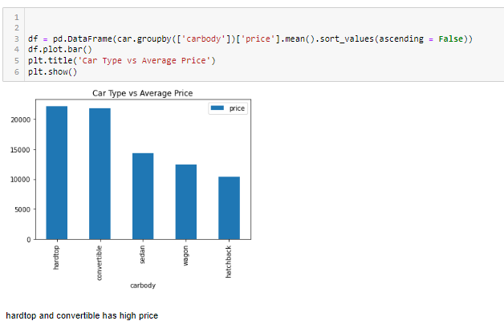

**CONCLUSION**

The increased prices of new cars and the financial incapability of the customers to buy them, Used Car sales are on a global increase. Therefore, there is an urgent need for a Used Car Price Prediction system which effectively determines the worthiness of the car using a variety of features. The proposed system will help to determine the accurate price of used car price prediction. This paper compares 3 different algorithms for machine learning : Linear Regression, Lasso Regression and Ridge Regression.